How To: Create Renders & Explosion Animations

Step 0: Define Appearances
Right click a component and click Appearance (or, use the A shortcut) 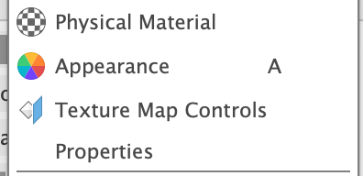
This allows you to edit the texture and look of the selected component.

Step 1: Create a Render
Before: After:

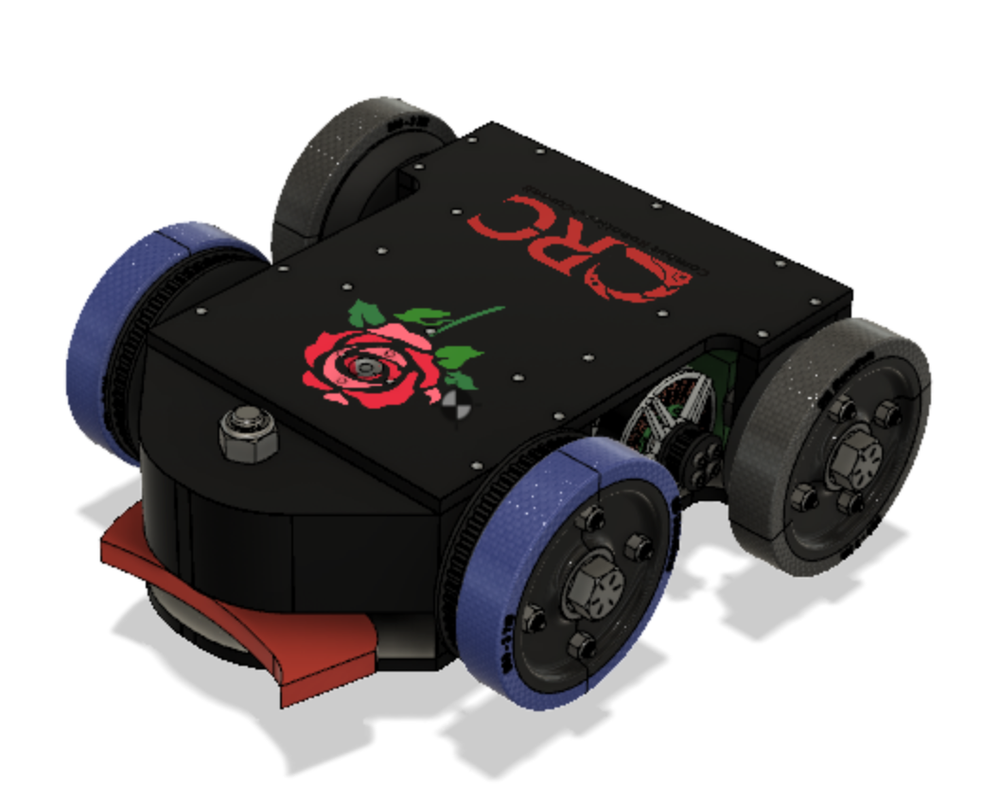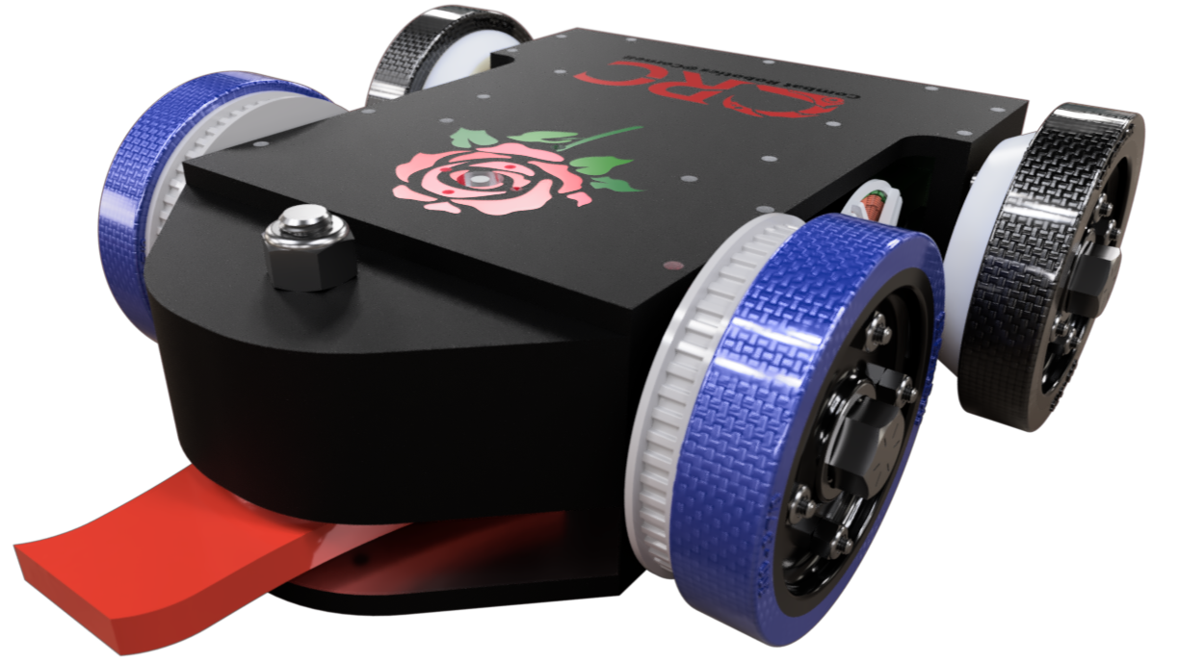

First, go to Render Tab (under left top corner where it says design)
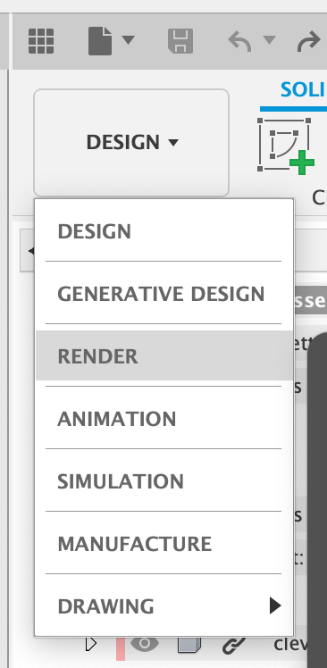
  - Generative Design = It does CAD for you
  - Render = Pretty Pics
  - Animation = Moving Videos
  - Simulation = Force/Stress/Heat Analysis
  - Manufacture = CNC Toolpaths
  - Drawing = Part Drawings for Manufacturing
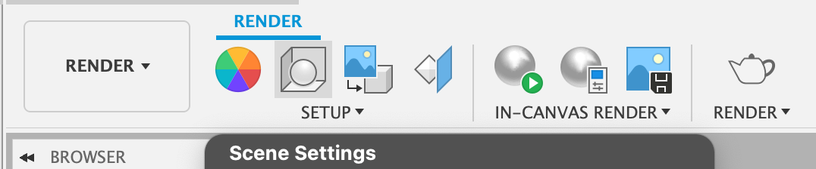
Top Bar Learning:

Appearances can also be changed here!
Scene Settings in all the Detail you’ll add to the “camera” and “scene”
In-Canvas Render is testing how it looks before doing the whole
Render Teapot is the FINAL picture (takes time and computationally a bit expensive, so make sure to render when you don’t need your laptop for a bit!)
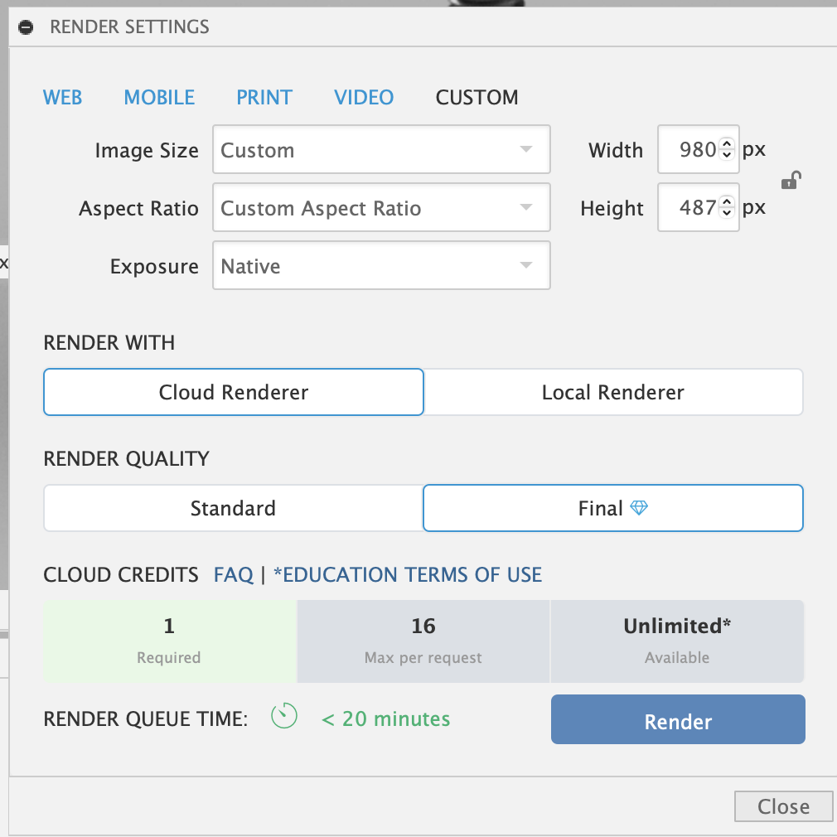

When content! Render the picture with a teapot!
If the pic is too small, zoom in next time or fix the aspect ratio
Make sure to use Cloud render unless you have a beefy graphics card (then you can use local render)
There will be a library of pics on the bottom once you render!

Step 2: Editing the Scene with Scene Settings

Three settings: Environment, Ground, Camera

Environment:
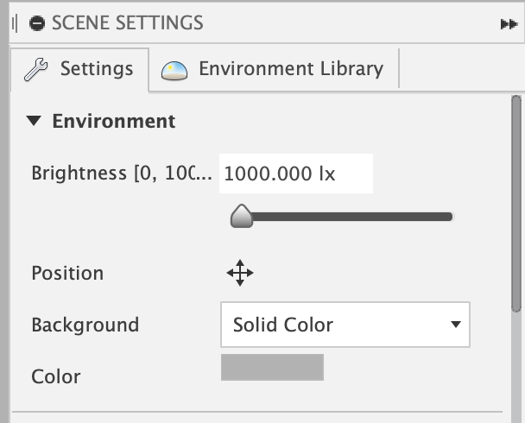
Brightness = Light on Object
Position = Position of environment and determines reflections and shadows (height + rotation of light)
Background = Color behind object
NOTE: Still use your mouse settings to move the object around!

Ground:

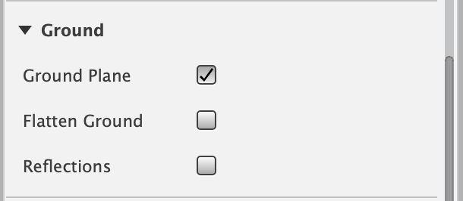
Ground Plane = creates the floor/ground, inserts shadows
Flatten Ground = puts object on the ground rather than in the air
Reflections = adds a reflection of the object like water to the ground

Camera
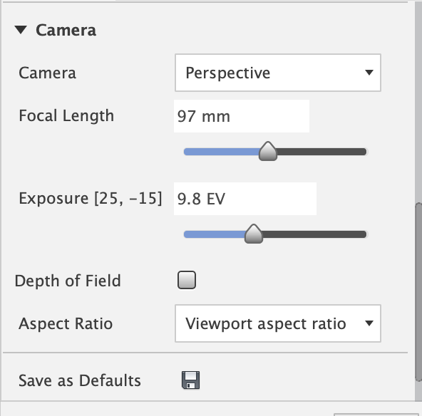
- Perspective view makes the setting look real
- Orthographic view is where all the lines in the shot are the same distance from the camera
Focal Length = Determines the feel of the object (small focal length makes the object feel bigger)
^ Can make it like a go pro!
Reminder: zoom in and pan to place the camera anywhere!
Exposure = how long the camera lens is open to collect light (brightness) (phones automatically adjust this)
Depth of Field = this is NOT visible until you start the In-Canvas render (this is the blur from things being too far or too close to the camera, note that the default is a loot of blur)
Aspect Ratio = the shape of the screen width over the height (16:9 is the most common and is what computers are)

Additional Settings
Environment Library = 3d world
polyhaven.com has good HDRI environments (files that define environments for Fusion 360 renders). Download .exr or .hdr files, then import into fusion by clicking the button in this photo.
You can make the transparent background only if the background is solid color and in the render dialogue you have to make sure transparent background is checked with png format

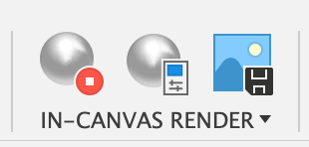
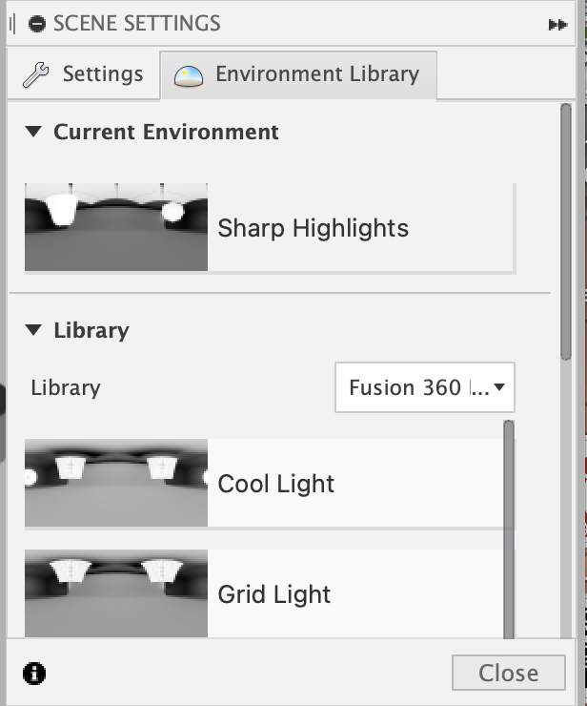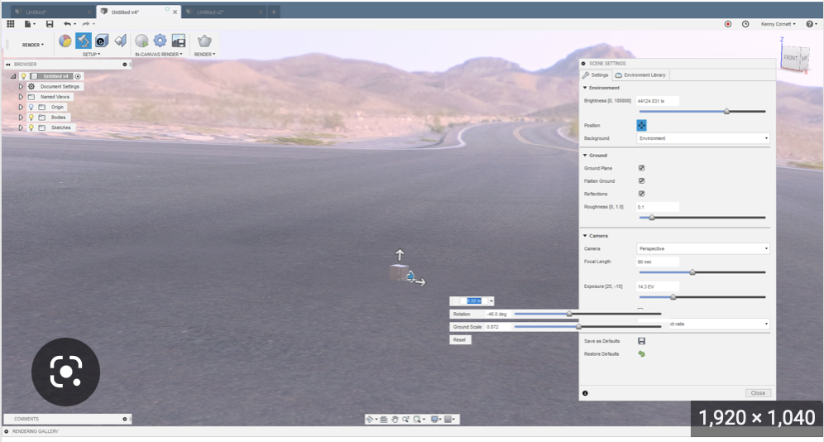
In-Canvas Render:
- When red it is rendering
- Settings (how nice it is level)
- There is a screenshot button
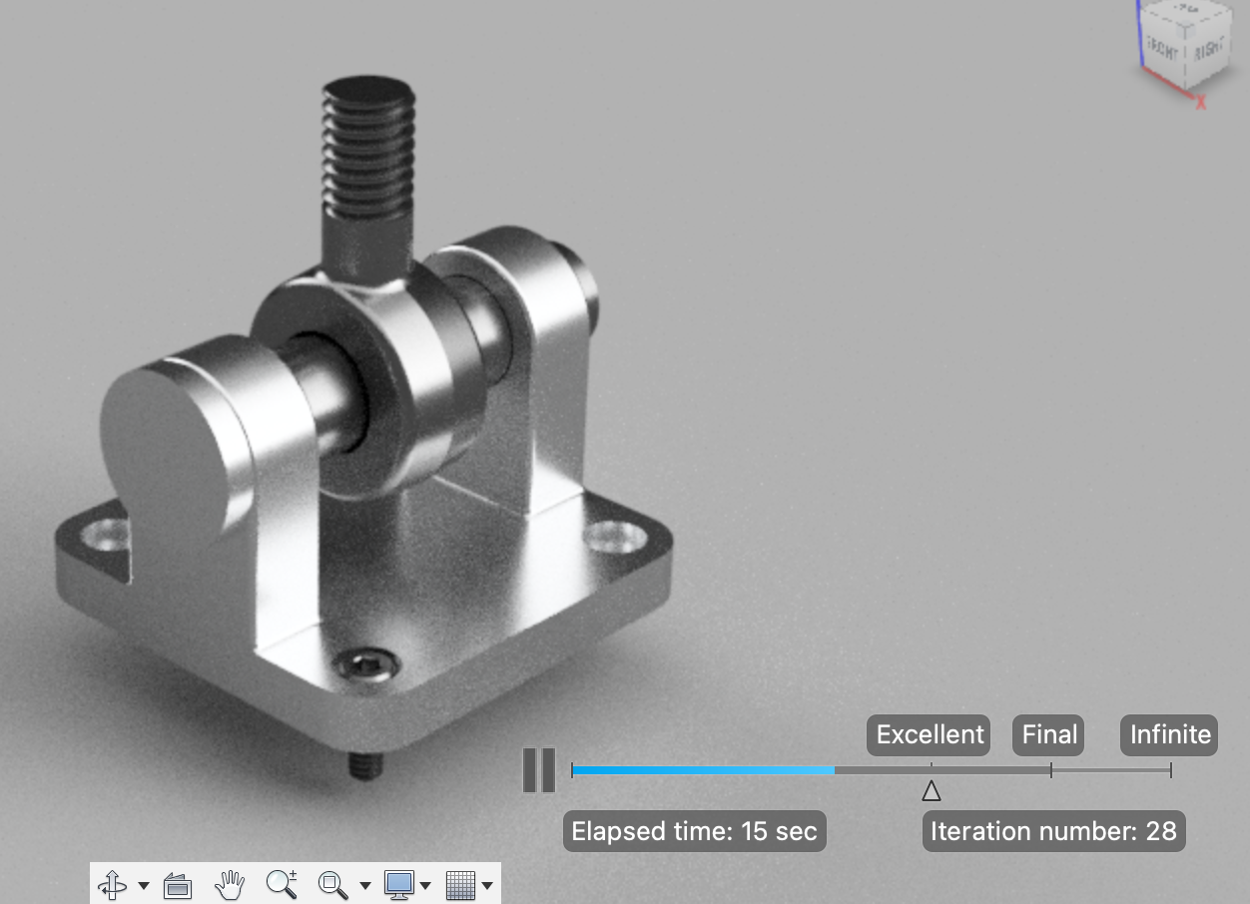

How to make an Explosion Animation
First: Go to the Animation tab in a full robot assembly

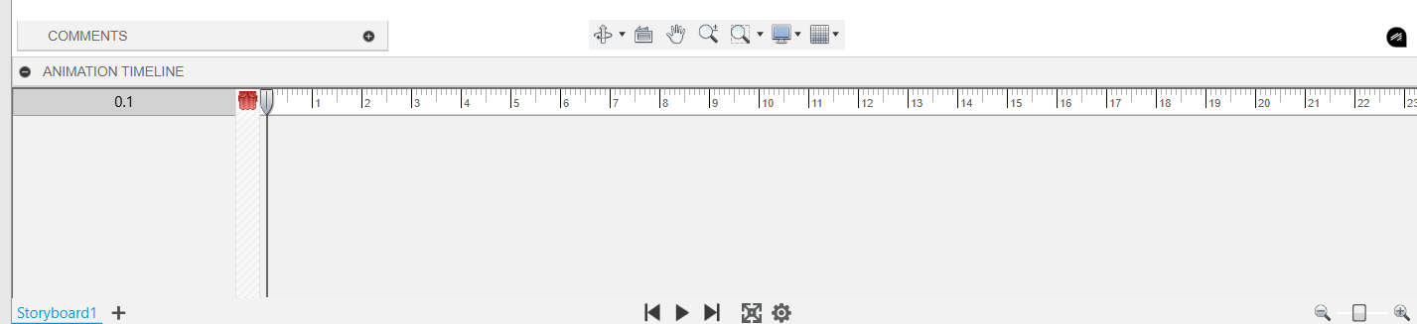

This is your Storyboard– as you begin animating components in the assembly, the movements will appear as actions in the storyboard, which can be moved around to any time.

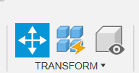
This button is the Transform Component button– click it and select a component to edit its X,Y, and Z distance, and angle.
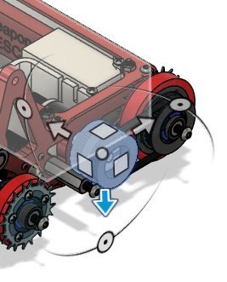
Drag your selected component to its final position. This animation should appear in your storyboard.
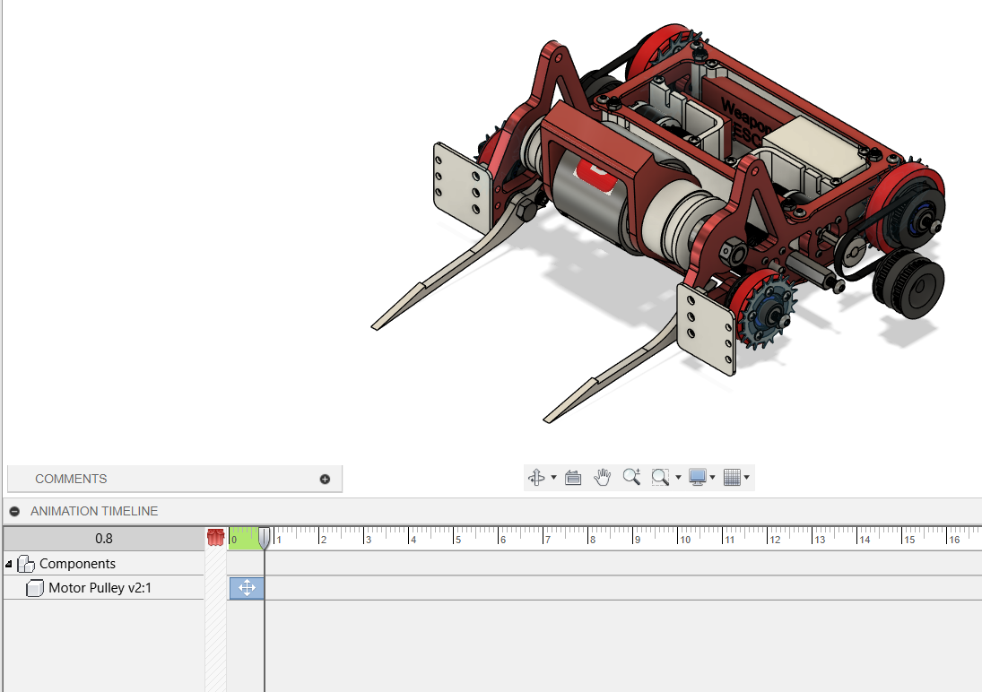

Keep on adding multiple different component animations until it’s sufficiently ‘exploded’.
Click Publish to export your animation!

Example:
Beater B. Barker FORK v20.avi

